ADVENT SERVICE
December 13, 2023

Prayer at the close of day |
“Prayer at the Close of Day” is a version of the historic rite called Compline. It is the final service of the day before one retires for the night. The congregation gathers in silence. Preservice music is omitted, and the lighting is subdued. The believer finds peace in God's forgiveness and security under the shadow of his wings.
In our Advent meditations, we focus our hearts on the character of Jesus. These responses that we speak and sing together give word to the desire of our hearts: that Jesus would come to us in his Word and Sacrament and that he will come soon at the end of time to set his people free.
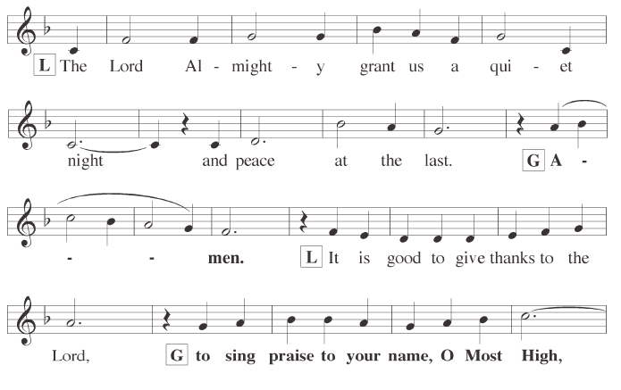
Opening Responses
Silence for meditation
Confession of sins
P: Our help is in the name of the Lord,
C: who made heaven and earth.
P: Let us confess our sins in the presence of God and of one another.
Silence for self-examination
P: I confess to God Almighty, before the whole company of heaven, and to you, my brothers and sisters,
that I have sinned in thought, word, and deed by my fault,
by my own fault,
by my own grievous fault;
wherefore I pray God Almighty to have mercy on me, forgive me all my sins,
and bring me to everlasting life.
C: The almighty and merciful Lord grant you pardon, forgiveness, and remission of all your sins.
P: Amen.
C: I confess to God Almighty, before the whole company of heaven, and to you, my brothers and sisters,
that I have sinned in thought, word, and deed by my fault,
by my own fault,
by my own grievous fault;
wherefore I pray God Almighty to have mercy on me, forgive me all my sins,
and bring me to everlasting life.
P: The almighty and merciful Lord grant you pardon, forgiveness, and remission of all your sins.
C: Amen.
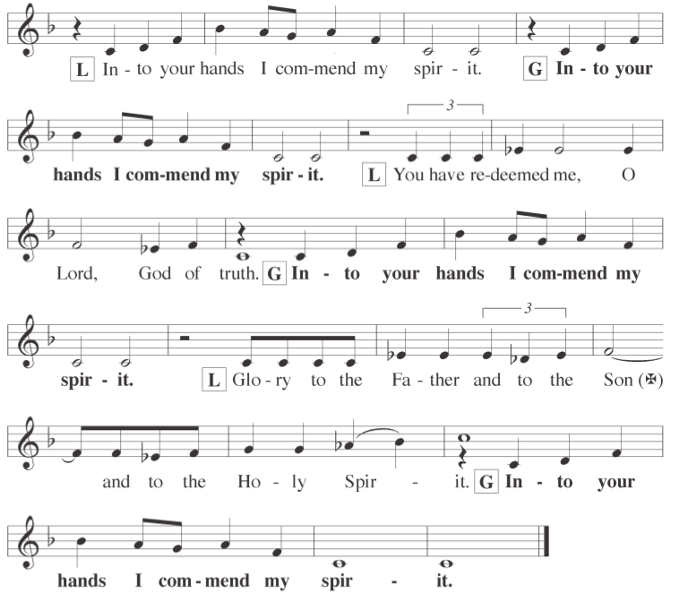

hymn God’s Own Son Most Holy| CW21 321

God’s Word Selections from John 15&16

The Son of God came to unite us to himself and give us peace.

“I am the true vine, and my Father is the gardener. He cuts off every branch in me that bears no fruit, while every branch that does bear fruit he prunes so that it will be even more fruitful. You are already clean because of the word I have spoken to you. Remain in me, as I also remain in you. No branch can bear fruit by itself; it must remain in the vine. Neither can you bear fruit unless you remain in me.

“I am the vine; you are the branches. If you remain in me and I in you, you will bear much fruit; apart from me you can do nothing. If you do not remain in me, you are like a branch that is thrown away and withers; such branches are picked up, thrown into the fire and burned. If you remain in me and my words remain in you, ask whatever you wish, and it will be done for you. This is to my Father’s glory, that you bear much fruit, showing yourselves to be my disciples.

“As the Father has loved me, so have I loved you. Now remain in my love. If you keep my commands, you will remain in my love, just as I have kept my Father’s commands and remain in his love. I have told you this so that my joy may be in you and that your joy may be complete. My command is this: Love each other as I have loved you. Greater love has no one than this: to lay down one’s life for one’s friends. You are my friends if you do what I command. I no longer call you servants, because a servant does not know his master’s business. Instead, I have called you friends, for everything that I learned from my Father I have made known to you. You did not choose me, but I chose you and appointed you so that you might go and bear fruit—fruit that will last—and so that whatever you ask in my name the Father will give you. This is my command: Love each other.

“If the world hates you, keep in mind that it hated me first. If you belonged to the world, it would love you as its own. As it is, you do not belong to the world, but I have chosen you out of the world.

That is why the world hates you. Remember what I told you: ‘A servant is not greater than his master.’ If they persecuted me, they will persecute you also. If they obeyed my teaching, they will obey yours also. They will treat you this way because of my name, for they do not know the one who sent me. If I had not come and spoken to them, they would not be guilty of sin; but now they have no excuse for their sin. Whoever hates me hates my Father as well. If I had not done among them the works no one else did, they would not be guilty of sin. As it is, they have seen, and yet they have hated both me and my Father. But this is to fulfill what is written in their Law: ‘They hated me without reason.’

“When the Advocate comes, whom I will send to you from the Father—the Spirit of truth who goes out from the Father—he will testify about me. And you also must testify, for you have been with me from the beginning.

Jesus went on to say, “In a little while you will see me no more, and then after a little while you will see me.”

Very truly I tell you, you will weep and mourn while the world rejoices. You will grieve, but your grief will turn to joy. A woman giving birth to a child has pain because her time has come; but when her baby is born she forgets the anguish because of her joy that a child is born into the world. So with you: Now is your time of grief, but I will see you again and you will rejoice, and no one will take away your joy. In that day you will no longer ask me anything. Very truly I tell you, my Father will give you whatever you ask in my name. Until now you have not asked for anything in my name. Ask and you will receive, and your joy will be complete.

“Though I have been speaking figuratively, a time is coming when I will no longer use this kind of language but will tell you plainly about my Father. In that day you will ask in my name. I am not saying that I will ask the Father on your behalf. No, the Father himself loves you because you have loved me and have believed that I came from God. I came from the Father and entered the world; now I am leaving the world and going back to the Father.”

Then Jesus’ disciples said, “Now you are speaking clearly and without figures of speech. Now we can see that you know all things and that you do not even need to have anyone ask you questions. This makes us believe that you came from God.”

“Do you now believe?” Jesus replied. “A time is coming and in fact has come when you will be scattered, each to your own home. You will leave me all alone. Yet I am not alone, for my Father is with me.

“I have told you these things, so that in me you may have peace. In this world you will have trouble. But take heart! I have overcome the world.”
Silence for meditation

hymn Creator of the Stars of Night| CW21 323

Message Colossians 1:9–13

For this reason, since the day we heard about you, we have not stopped praying for you. We continually ask God to fill you with the knowledge of his will through all the wisdom and understanding that the Spirit gives, so that you may live a life worthy of the Lord and please him in every way: bearing fruit in every good work, growing in the knowledge of God, being strengthened with all power according to his glorious might so that you may have great endurance and patience, and giving joyful thanks to the Father, who has qualified you to share in the inheritance of his holy people in the kingdom of light. For he has rescued us from the dominion of darkness and brought us into the kingdom of the Son he loves.

hymn Christ, The Word of God Incarnate| CW 528

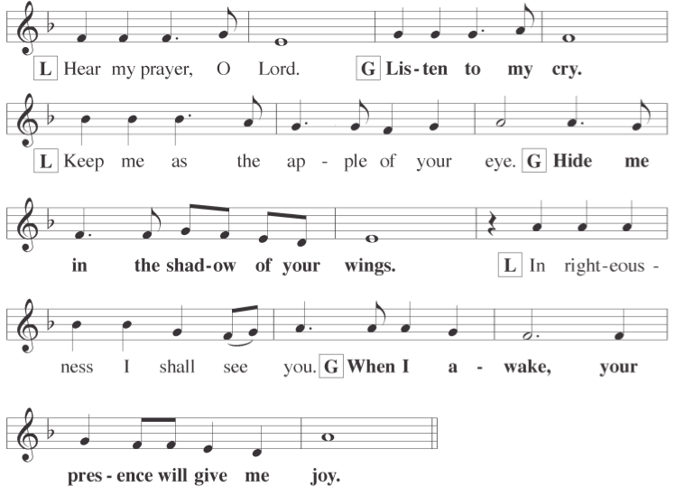
PRAYER

P: Be present, O merciful God, and protect us through the silent hours of this night, so that we who are wearied by the changes and chances of this fleeting world may rest in your eternal changelessness. Look down, O Lord, from your heavenly throne, and illuminate this night with your celestial brightness, that by night as by day your people may glorify your holy name; through Jesus Christ our Lord.

C: Amen.

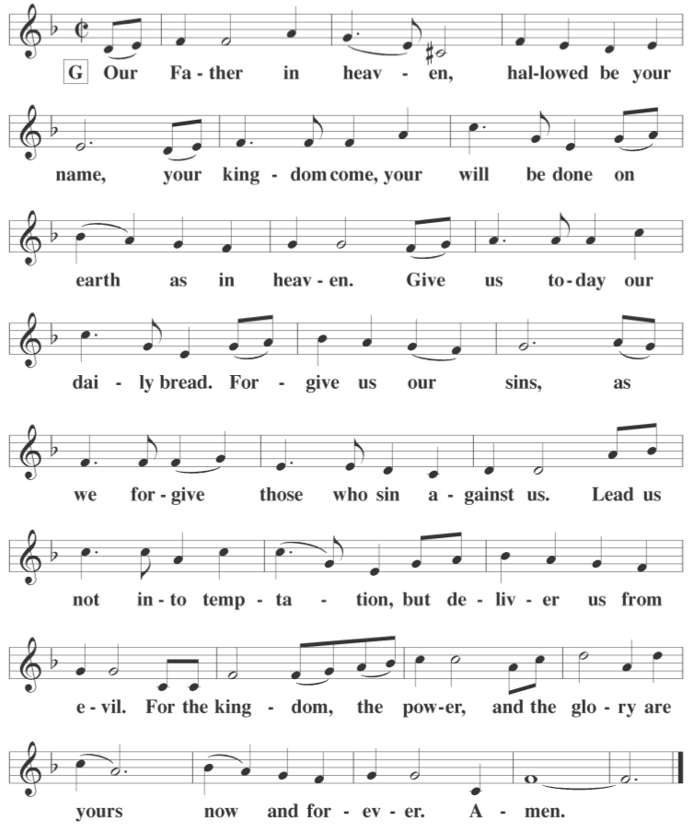
THE LORD’S PRAYER

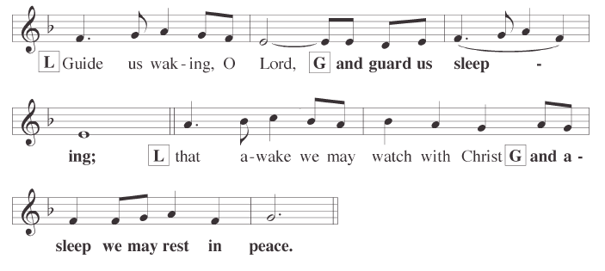

GOSPEL CANTICLE
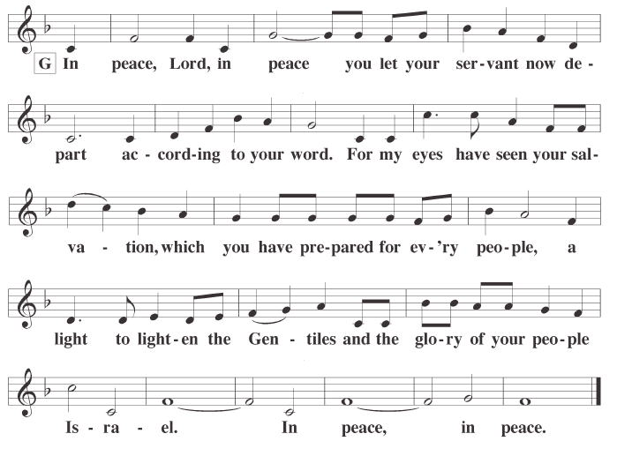

THE BLESSING
P: The almighty and merciful Lord, the Father, the Son, ✝ and the Holy Spirit, bless us and keep us.
C: Amen.

hymn Abide With Me| CW21 783

13009 N. Elderberry Ct.
Lodi, CA 95242
www.christlodi.org
209-368-6250
Pastor Timothy Leistekow
WELCOME TO CHRIST EV. LUTHERAN CHURCH!
We preach a message of forgiveness, hope and peace
through the death and resurrection of Jesus Christ.
Families and individuals of all ages will find opportunities
both to grow and to serve.
Our mission statement:
Look what Christ is doing!
He binds us together in fellowship
He gathers us in for worship
He builds us up for service
He sends us out with the gospel

“Now you are the body of Christ,
and each one of you is a part of it.”
(1 Corinthians 12:27)

